Board of Directors Nominee Biographies
2021 Annual Meeting

William D. Laundry
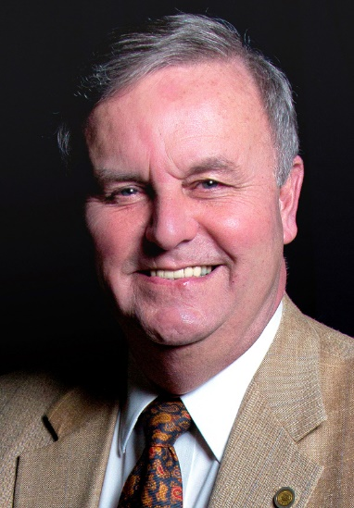
William (Bill) Laundry has lived and worked in Plattsburgh since 1969 and has been a member of UFirst since 1972. He worked for SUNY Plattsburgh and after a 44-year career, retired as Vice President of Student Affairs.

Bill has served on the UFirst Board of Directors since 1985 and presently serves as Vice Chair. During his time as a Board of Director, he has served on several committees. Bill also volunteers with the Clinton County Historical Association, the Plattsburgh Memorial Chapel and the Ausable Forks High School Alumni Association.

Bill appreciates the opportunity to continue working with the Board of Directors and the excellent team of UFirst FCU.

